

Rosanna Cub Scouts
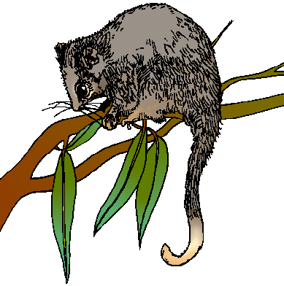
Activity: Possum Prowl
When: 27th May, 2014

Start Time: Arrive 6:45pm – need to make arrangements and tour starts at 7 sharp

Finish Time: 8.30pm

Cost: $10 each participant.
Where: La Trobe University
Wildlife Reserve

Meet at:
Wildlife Reserve Office – enter from
LaTrobe Ave (between Main Dve
and Ring Rd – Melway 19 G5)
Don’t be late… call 0411 121 495 if
any problems.

What to wear:
Cub Uniform
Solid Footwear for walking
Dress for warmth and bring a coat if necessary, waterproof gear if raining
No torch – Adults only (don’t want to affect night vision)

What we will see:
Good Question! It depends on two things.
1. How noisy you are!
2. The Weather – if it’s raining, it may STILL be on, so wear waterproof gear and have fun!

A ranger will take us on a guided tour, so we’ll see as much as we can.

WE NEED TO KNOW NUMBERS ASAP… PLEASE ADVISE AKELA HOW MANY YOU WILL HAVE ATTENDING ON: 0411 121 495 OR akela@rosannacubs.org

NOTE: that we have a cap of 30 people…. Unfortunately we can’t take any more on the tour.
With regards to parents/siblings… first in, best dressed after Cubs included, so don’t delay!

